**Appendix B**

**Analysis**

**-Sandu, Mircea-**

**Use case diagram** **2**

**Use case descriptions and activity diagrams** **3**

Register an account 3

Manage funds account 6

Manage bank account personal data 9

Transfer funds to own/foreign accounts in different currencies 13

Take loans in danish kroners 14

Approve new customer 16

Manage client data 18

Shut down the banking server 19

Manage staff account 21

Manage Exchange rate 23

**Database ER Diagram** **25**

# Use case diagram

# Use case descriptions and activity diagrams

## Register an account

|  |  |
| --- | --- |
| **Use case** | **Register an account** |
| **Summary** | It is possible to register an new account |
| **Actors** | Customer |
| **Precondition** |  |
| **Postcondition** | The account is created and the customer await for the account approval by staff. |
| **Base sequence** | 1. Press the “Sign up” button. 2. Type your full legal name in the required field. 3. Type your CPR number in the required field. 4. Type your address in the required field. 5. Type your phone number in the required field. 6. Type your email in the required field. 7. Type your password in the required field. 8. Confirm your password in the required field. 9. Press the “Sign Up “ button. |
| **Exception sequence** | 2a. If the name contains or is containing numbers go back to step 2.  3a. If the CPR is invalid go back to step 3.  4a. If the Address is invalid go back to step 4.  5a.If you inserted letters as your phone number instead of numbers go back to step 5  5b. If you inserted a phone number which does not contain exactly eight digits go back to step 5.  7a.If you inserted a new password which is shorter than 8 characters go to step 7.  8a.If you inserted a wrong password in the “Confirm new password” field , go to step 8. |
| **Note** | Name should contain only letters.  CPR should contain no more or no less than 10 digits.  Address should not be contained only from numbers.  Phone number should be only a combination of numbers no more and no less than eight digits.  Password can be either an only number password , only letters password or a combination between letters and numbers. |

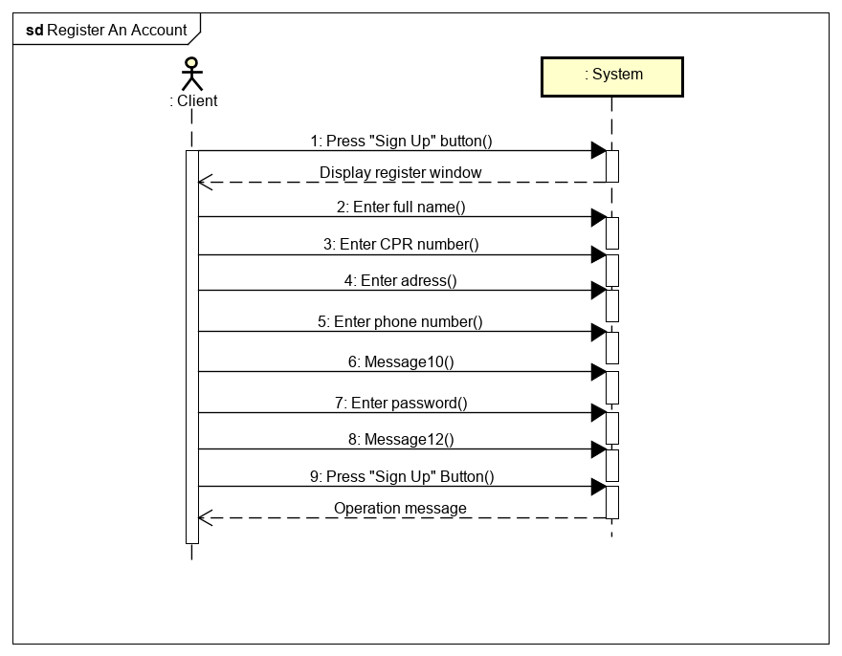

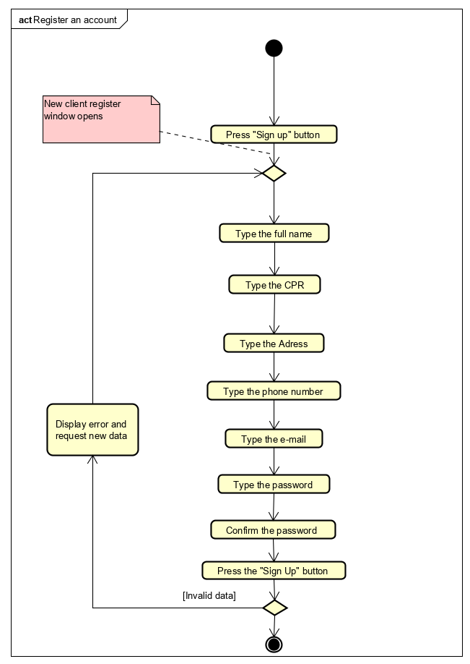

## Manage funds account

|  |  |
| --- | --- |
| **Use case** | **Manage funds accounts** |
| **Summary** | A valid amount of funds can be deposited into the customer’s account or withdrawn from it , customer can close ( delete ) on of his account or he can open a new one in a preferred currency. |
| **Actors** | Customer |
| **Precondition** | 1. For depositing: An account with the corresponding account number must exist. 2. For withdrawing: The account must exist. |
| **Postcondition** | 1. For depositing: The selected amount will be deposited on the account with the corresponding account number. 2. For withdrawing: The selected amount will be withdrawn from the selected account. |
| **Base sequence** | I) For depositing:   1. Select the account number of the desired account from the drop-down list. 2. Enter the desired amount you wish to deposit. 3. Click “Deposit”.  * If the entered amount is illegal, go to step 2.   II) For withdrawing:   1. Select the account number from the drop-down list. 2. Enter the desired amount you wish to withdraw. 3. Click “Withdraw”   III) For closing an account:   1. Select the account number from the drop-down list. 2. Press “Delete” button. 3. In the pop-up window press “ok” if you are sure to delete this specific account or press “cancel” and go to III step 1.   IV) For opening an account:   1. In the “Accounts” section , select a currency in which you want to open the account. 2. Add an description or leave it blank. 3. Press “Create” button. 4. In the pop-up window press “ok” if you are sure to open this specific account or press “cancel” and go to IV step 1. |
| **Exception sequence** | I)2a. If the entered amount is illegal or greater than the one currently existing in the account, go to I step 2.  II)2a. If the entered amount is illegal or greater than the one currently existing in the account, go to II step 2.  III)2a. If the selected account is not empty go back to III step 1. |
| **Note** | The entered amount must only be made up of positive numbers, not greater than 2 147 483 647.  Main account DKK cannot be deleted.  If the account is not empty and it's not possible to be deleted , just transfer the money to an another account. |

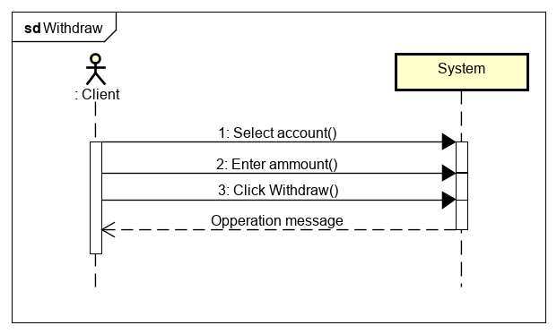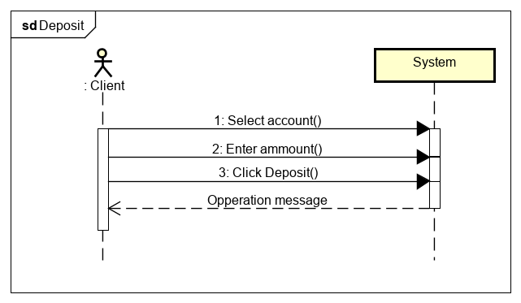

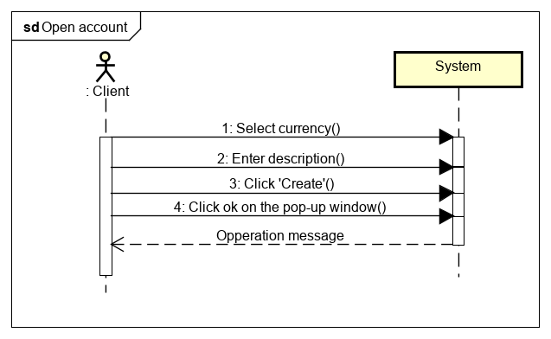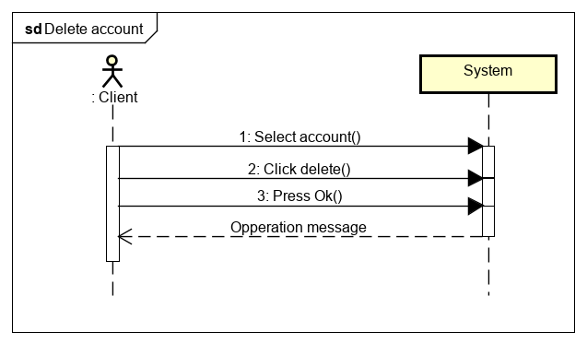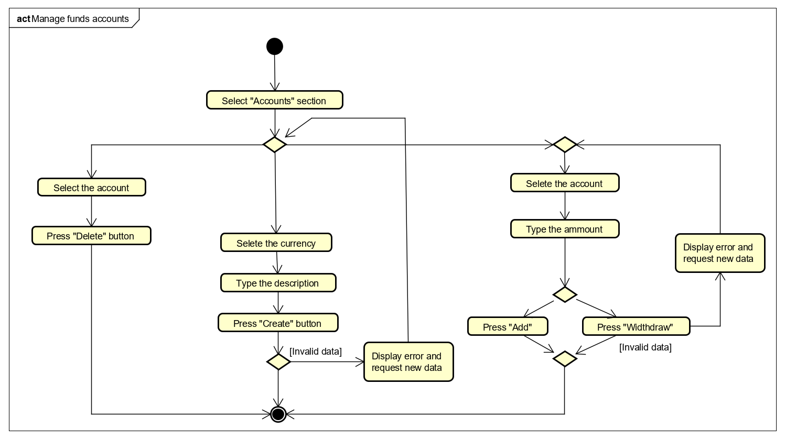

## Manage bank account personal data

|  |  |
| --- | --- |
| **Use case** | **Manage bank account personal data.** |
| **Summary** | Personal data stated at the beginning of the creation of the account can be modified. |
| **Actors** | Customer |
| **Precondition** |  |
| **Postcondition** | The selected fields which contained the specific information will be updated with the new given data by the customer. |
| **Base sequence** | 1.Login  2. Go to “Settings” section.  I)For deleting account:   1. Press the “Delete Account” button. 2. In the pop-up window press “OK” if you are sure to delete your account or press “Cancel” and go to step 1.   II)For changing your password:   1. Type your old password in the required field. 2. Type your new password in the required field. 3. Confirm your new password in the required field. 4. Press the “Change password” button. 5. In the pop-up window press “OK” if you are sure to change your password or press “Cancel” and go to step 1,2 or 3.   III)For changing your phone number:   1. Think about a new phone number. 2. Type your new phone number in the required field. 3. Press the “Change number” button. 4. In the pop-up window press “OK” if you are sure to change your phone number or press “Cancel” and go to step 1 or 2.   IV)For changing your address:   1. Think about a new address. 2. Type your new address in the required field. 3. Press the “Change address” button. 4. In the pop-up window press “OK” if you are sure to change your address or press “Cancel” and go to step 1 or 2. |
| **Exception sequence** | II)1a.If you inserted the wrong old password go to II step 1.  2a.If you inserted a new password which is shorter than 8 characters go to II step 2.  2b.If you inserted in the “New Password” the same password as old one, go to II step 2.  3a.If you inserted a wrong password in the “Confirm new password” field , go to II step 3.  III) 2a.If you inserted letters as your phone number instead of numbers go back to III step 2.  2b. If you inserted a phone number which does not contain exactly eight digits go back to III step 2.  IV) 2a.If you inserted only numbers for your new address , got to IV step 2. |
| **Note** | You can make a request to have your account and all its data deleted.After you press the delete button you have 6 months to log back or your account and personal data will be deleted.  Password can be either a only number password , only letters password or a combination between letters and numbers.  Phone number should be only a combination of numbers no more and no less than eight digits.  Address should not be contained only from numbers. |

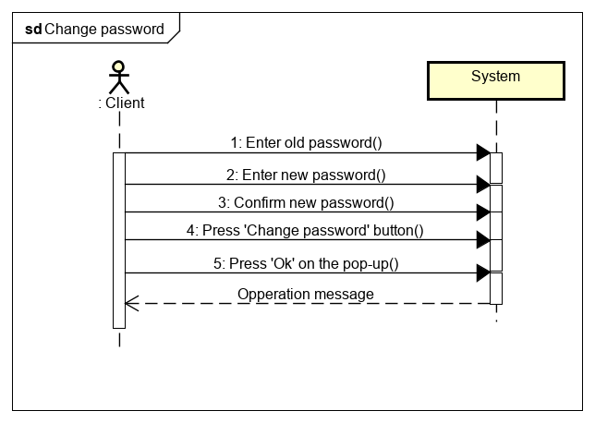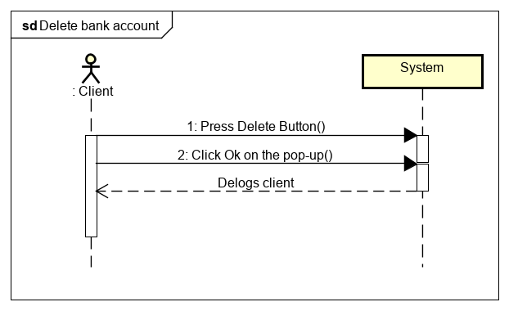

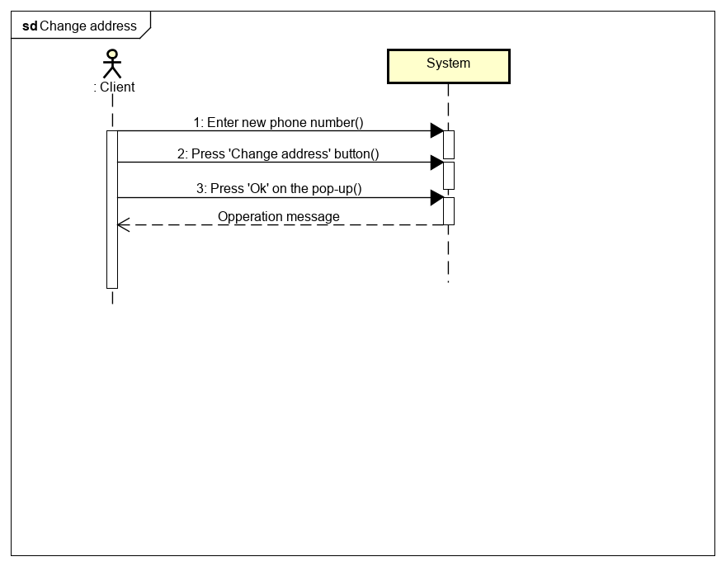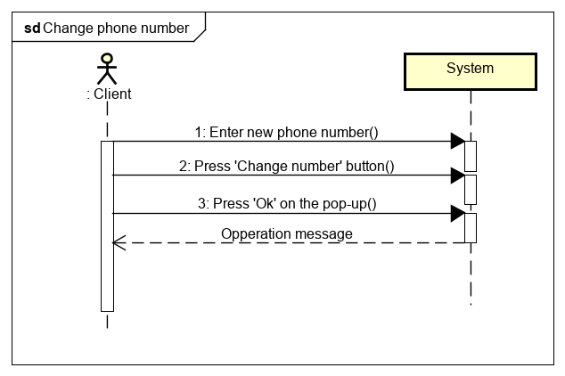

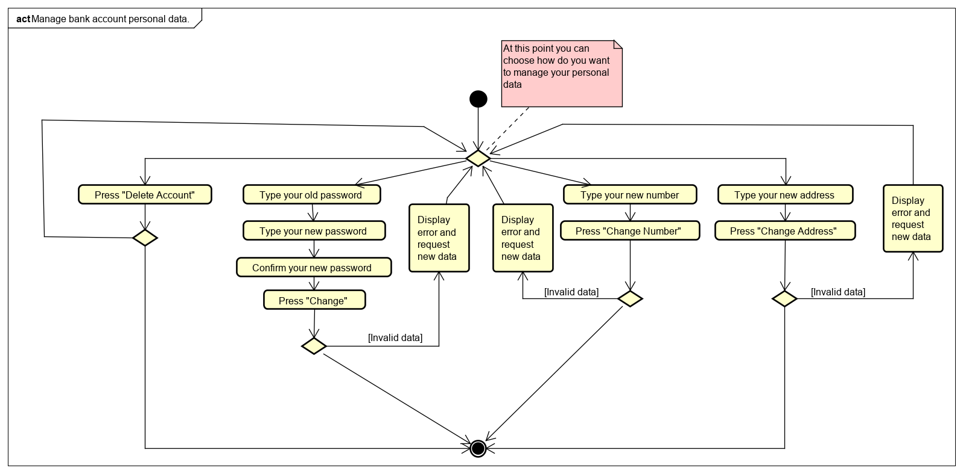

## Transfer funds to own/foreign accounts in different currencies

|  |  |
| --- | --- |
| **Use case** | **Transfer funds to own/foreign accounts in different currencies** |
| **Summary** | A valid amount of funds is transferred from one account to another, be it to one from the same customer, or another. |
| **Actors** | Customer |
| **Precondition** | Both the accounts from/to which one wishes to make the transfer already exist. |
| **Postcondition** | The selected amount is transferred from one account to another. |
| **Base sequence** | I)For transfering funds to a foreign account:   1. Select the account number from which you wish to make the transfer, from the drop-down list. 2. Type the desired foreign account number. 3. Type the desired amount you want to transfer. 4. Press “Transfer” button. 5. In the pop-up window press “ok” if you are sure to transfer the money or press “cancel” and go to step 1.   II)For transfering funds to your own account:   1. Select the account number from which you wish to make the transfer, from the drop-down list. 2. Select the account number to which you wish to make the transfer, from the drop-down list. 3. Type the desired amount you want to transfer. 4. Press “Transfer” button. 5. In the pop-up window press “ok” if you are sure to transfer the money or press “cancel” and go to step 1. |
| **Exception sequence** | 5a. If the desired amount is illegal or chosen account does not have enough funds , go back to I step 3 or go back to II step 3. |
| **Note** | Transfers between accounts of different currencies will be automatically exchanged in the required currency.  The transfer amount must only be made up of positive numbers, not greater than 2 147 483 647. |

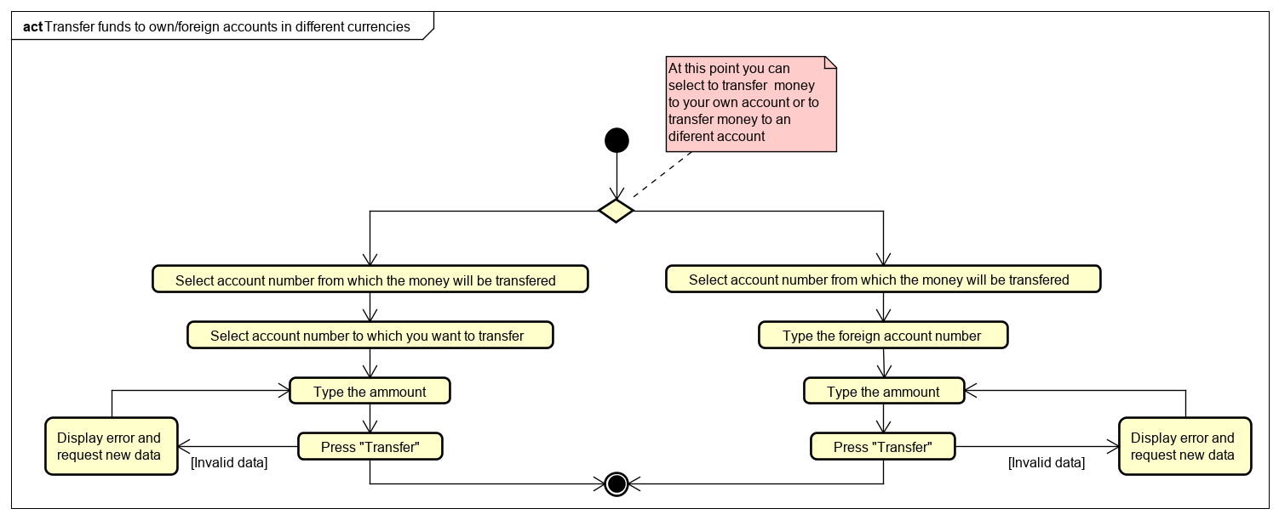

## Take loans in danish kroners

|  |  |
| --- | --- |
| **Use case** | **Take loans in danish kroners** |
| **Summary** | A valid amount of funds can be taken as a loan only in the main account in its corresponding currency. |
| **Actors** | Customer |
| **Precondition** | 1. The loan should be confirmed by one of the staff members. |
| **Postcondition** | The selected amount taken as a loan will be transferred into your main account. |
| **Base sequence** | 1. Think about the number of funds you want to take as a loan. 2. Enter the number of loans in the required field for it “ Amount” 3. Press “Request Loan” button. 4. In the pop-up window press “ok” if you are sure to request this specific amount or press “Cancel” and go to step 1. 5. Wait for approval from one of the staff members. |
| **Exception sequence** | 2b. If the desired amount is illegal or greater than the amount which can be considered as a loan, go back to step 2. |
| **Note** | Loans can be requested only on the main account.  The loan amount must only be made up of positive numbers, not greater than 2.000.000 danish kroner. |

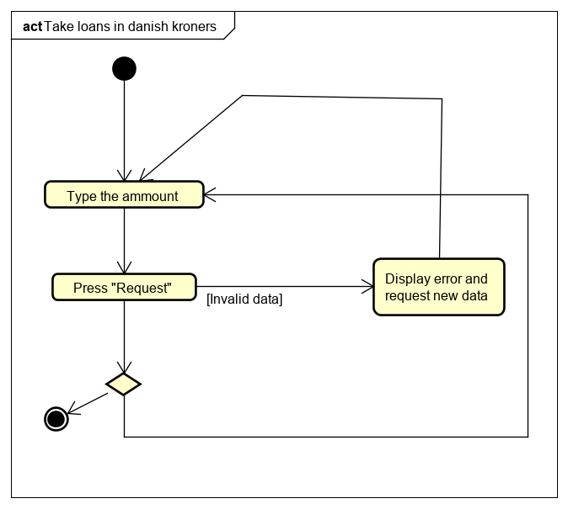

## Approve new customer

|  |  |
| --- | --- |
| **Use case** | **Approve new customer** |
| **Summary** | Allows Staff to approve the creation of an account for the new customer. |
| **Actors** | Staff |
| **Precondition** | Client should have signed up for the creation of a new account. |
| **Postcondition** | A new , fresh account will be registered with zero funds. |
| **Base sequence** | 1. Login as a Staff member.  2. Go to the “Accept new clients” section.  3. Select a specific account which will be accepted.  4.Double click on the account.  5.In the pop-up window press “OK” if you are sure to approve this specific client or press “Cancel” and go to step 3. |
| **Exception sequence** |  |
| **Note** | To accept new clients you should be a staff member. |

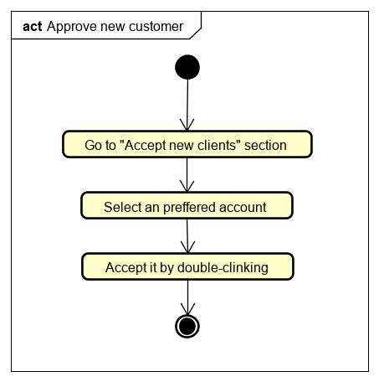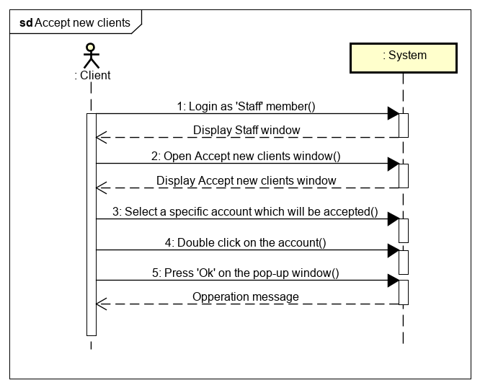

## Manage client data

|  |  |
| --- | --- |
| **Use case** | **Manage client data** |
| **Summary** | Allows Staff members to change customers password and to accept loans. |
| **Actors** | Staff |
| **Precondition** | For accepting the loans a client should have sent an loan request. |
| **Postcondition** | Client password will be changed and his loan request will be accepted , therefore he will get an specific amount of money as a loan. |
| **Base sequence** | 1. Login as a Staff member. 2. Go to “Manage clients”section.   I) For accepting the loans:   1. Select the specific client whose loan will be accepted from the loans table. 2. Double click on the selected client. 3. In the pop-up window press “OK” if you are sure to approve this specific loan or press “Cancel” and go to step 1.   II) For changing client password:   1. Type CPR number in the required field. 2. Type the new password. 3. Confirm the new password in the required field. 4. Press the “Change password” button.   III) For retrieving client data:   1. Type CPR number in the required field. 2. Press “Retrieve data” button. |
| **Exception sequence** | II)1a.If you inserted a wrong client CPR go to II step 1.  2a.If you inserted a new password which is shorter than 8 characters go to II step 2.  3a.If you inserted a wrong password in the “Confirm new password” field, go to II step 3.  III) 2a.If you inserted a wrong client CPR number go to III step 1. |
| **Note** | Password can be either an only number password , only letters password or a combination between letters and numbers.  You cannot retrieve data of an another staff member or manager. |

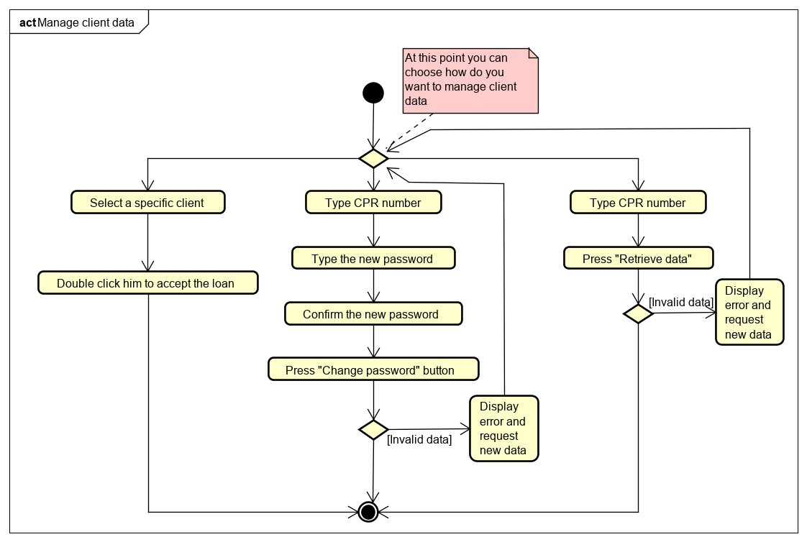

## Shut down the banking server

|  |  |
| --- | --- |
| **Use case** | **Shut down the banking server** |
| **Summary** | Allows an manager to shut down the application server in a controlled manner. |
| **Actors** | Manager |
| **Precondition** | The banking server should be running.  You are logged in as the manager. |
| **Postcondition** | The banking server gets shuts down. |
| **Base sequence** | 1. Login as a manager.  2. Go to the “Manager” section.  3. Click “Close server”.  3. The application server shuts down. |
| **Exception sequence** |  |
| **Note** | To shut down the banking server you must be a Manager. |

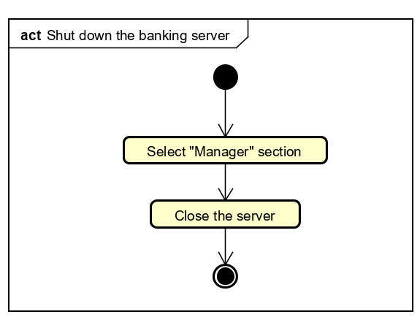

## Manage staff account

|  |  |
| --- | --- |
| **Use case** | **Manage Staff account** |
| **Summary** | Allows an manager to create/delete or change the password for an staff member. |
| **Actors** | Manager |
| **Precondition** | You are logged in as the manager. |
| **Postcondition** | Staff members account get created/deleted/edited. |
| **Base sequence** | 1. Login as a manager.  2. Go to the “Manager” section.  I)Create new staff.   1. Type staff’s full legal name in the required field. 2. Type staff’s CPR number in the required field. 3. Type staff’s password in the required field. 4. From the drop-down list select his position. 5. Press “Create staff” button. 6. In the pop-up window press “ok” if you are sure to create this new account or press “cancel” and go to V step 1/2/3/4.   II)Delete Staff.   1. From the drop-down list select the specific staff’s CPR number 2. Press “Delete staff” button. 3. In the pop-up window press “ok” if you are sure that you want to delete this specific account or press “cancel” and go to V step 1.   III)Change staff Password.   1. Type new password in the required field. 2. Confirm the new password in the required field. 3. From the drop-down list selected the specific staff’s CPR number. 4. Press “Change password” button. |
| **Exception sequence** | I)1a. If the name contains or is containing numbers go back to step 1.  2a. If the CPR is invalid go back to step 2.  3a.If you inserted a new password which is shorter than 8 characters go to step 3.  III)1a.If you inserted a new password which is shorter than 8 characters go to III step 1.  2a.If you inserted a wrong password in the “Confirm new password” field, go to III step 3.  4a.If you did not select from the drop down list staff’s CPR number go back to III step 3. |
| **Note** | To delete a staff account you must be a Manager.  To create a staff account you must be a Manager.  To change a staff’s password you must be a Manager.  Name should contain only letters.  CPR should contain no more or no less than 10 digits.  Password can be either an only number password , only letters password or a combination between letters and numbers. |

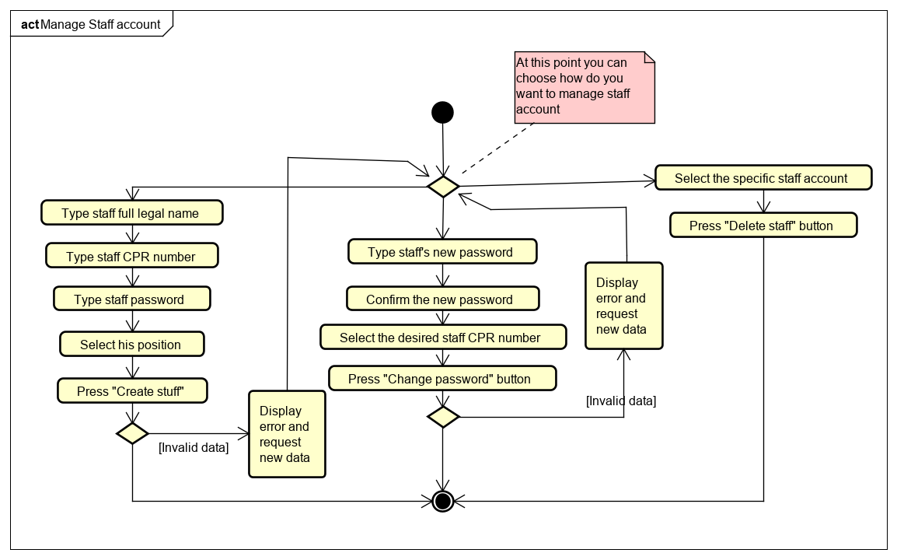

## Manage Exchange rate

|  |  |
| --- | --- |
| **Use case** | **Manage Exchange Rate** |
| **Summary** | Allows a manager to view or edit the exchange rate of a specific currency. |
| **Actors** | Manager |
| **Precondition** | Currencies must exist in the system. |
| **Postcondition** | Currency exchange rates get changed. |
| **Base sequence** | 1. Login as a manager.  2. Go to the “Manager” section.  3. The system shows in a table all exchange rates  5. Select the desired currency to which you wish to change its exchange rate,from the drop-down list.  6. Type the desired new exchange rate.  7. Press the “Change rate” button.  8. In the pop-up window press “ok” if you are sure to change the specific exchange rate or press “cancel” and go to step 5. |
| **Exception sequence** | 8a. If the value of a currency exchange rate is invalid, go to step 5. |
| **Note** | The exchange rates for all the foreign currencies are shown based on the danish krone (DKK) rate.  The exchange rate must be a positive number or an error will be displayed. |

# 

# Database ER Diagram

